**Ecotherapy**

18 May 2022 10:56 am

***The importance of the environment in education for sustainability and children’s wellbeing***

Dr Poppy Gibson and Aoja Aron

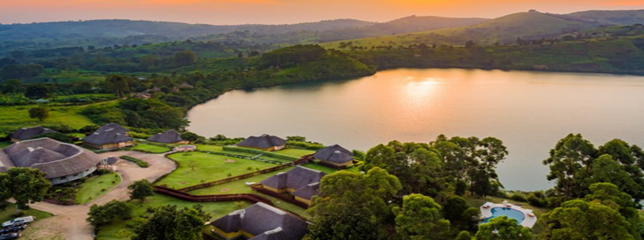

‘Ecotherapy’ is a therapeutic strategy that draws upon environmental or ecological interventions. Spending time in nature is proven to benefit health and wellbeing (Gibson and Bale, 2021). Ecotherapy can act as a tool for helping to promote positive mental health and wellbeing in children and young people. When we are living in an age that sees us overwhelmed with cognitive load, taking the opportunity to seek solace and learn in outdoor spaces can have significant benefits on both our physical and mental health. Comorbid with this is our emergence from the SARS-CoV-2 pandemic; this blog post encourages the reader to consider how we can help our children and young people ‘recover with nature’ (Chaudhury and Banerjee, 2020), utilising aspects of our world around us to promote positive wellbeing through five simple and practical activities.

The environment is key to the existence of life on earth but there is a drastic over dependence and encroachment on the different natural resources within the environment. It is a natural gift of nature and we need to conserve it for our existence. The environment is important to us through the benefits below:

* **Forests**

The environment is a source of construction materials such as timber, poles, and papyrus reeds and also protects a lot and shelters from harsh weather acting as windbreaks. Forests (trees) through the process of photosynthesis absorb carbon dioxide a raw material used to manufacture their food thus releasing oxygen that living things use for breathing and that justifies the importance of acting as carbon sinks purifying the environment. Forests and other green vegetation are essential in rainfall formation through the process of evaporation and evapotranspiration where water vapor rises and condenses resulting in rain that recharges the water cycle essential for plant, human and agricultural consumption.

**Forest teaching activity:** Arrange to take your class into a forest or woodland area. Speak about how trees are just like us; from far away it is a group of trees, but up close each is individual and unique. Look at the rings on any felled trees. Encourage sensory interaction by feeling the bark of the trees, or enjoy sketching a tree and seeing if a partner can recognize it from the specific markings they have annotated on their drawing.

* **Soil**

Soil is a useful component in the environment for the growth of plants through the fertility of the top layer rich in humas essential for seed germination, which provides food security to animals and humans. The soils in the environment can be used for pottery work such as clay, other types of soil can also heal some diseases when someone smells or touches the soil and others use it for construction raw materials like bricks.

**Soil teaching activity:**Encourage the children to test growing plants in different soils (one with clay, one with sand, etc.); which is best for plant growth? Look at soil through a sieve and microscope and look at the insects that live in our soils.

* **Food and medicine**

The environment is a source of food obtained from plants and animals where we obtain different nutrients from their consumption such as carbohydrates, fats, proteins from meat, fish, milk, eggs, honey, and vitamins from fruits which are a source of a health boost to fight against diseases such as malnutrition. We obtain many medicines from medicinal plants and animals. These drugs are compatible with human bodies with minimal or no side effects and most of these are in Africa such as Aloe vera and Moringa. Different leaves and roots cure ulcers, stomach upsets, malaria, skin infections, and coughs among others. Most of these medicines through more research and tests are developed into drugs that are used to cure different diseases.

**Food and medicine teaching activity:**Grow some vegetables or fruits with your class. You don’t need a large outdoor space- you can grow in a compost grow bag if you do not have flowerbeds to access.

* **Bees and pollination**

The environment helps in preventing disease spread. This is because there is a high chance of disease spread in closed environments because the environment absorbs harmful toxic wastes from pollution. The different components within the environment add beauty such as flowers, trees and other physical features that make it gorgeous and attractive to watch. The environment has insects like bees that carry out pollination of flowers of plants in the environment resulting in food production. Bees also produce honey which is used as herbs for food and medicine.

**Pollination teaching activity**: Plant a wildflower seed bed- or if you don’t have access to flowerbeds, use some plant pots and use them to brighten up your classroom as they grow. Wildflower seed mix usually contains hardy seeds like poppies that should grow well in most environments. Give the children responsibility for watering the seeds with a class rota. Move the plants outside and observe if bees visit.

* **Using the outdoors in learning**

The environment helps in controlling stress. This is through the different natural resources like lakes, oceans, beaches, forests, mountains, game parks and reserves. These features help in relaxing the mind from stressful environments and could be done through game drives, nature walks, swimming, saunas and other forms of rest during summer, winter, autumn and spring. Key features like hot springs in the environment are believed to heal people when they bathe in the springs with their special water.

**Outdoor learning ideas:** Try taking some of your lessons outdoors; lessons such as guided reading or independent reading, where the children do not need many resources but can keep focus. Use outdoor spaces for PSHE lessons to reflect upon how we are feeling, in spaces detached from our busy classrooms.

**Conclusion**

However beautiful the environment is and adds a lot of value, other people don’t appreciate the beauty, thus leading to the destruction of the environment through deforestation, pollution from oil and other mineral fields, wetlands, and other encroachment on other natural resources that threaten the above benefits of the environment. Teaching children about our environment and encouraging them to interact with it in a respectful and purposeful way not only promotes sustainability but also offers therapeutic benefits in terms of reduced stress and anxiety, and more positive feelings of happiness and wellbeing.

**Coauthored with Aoja Aron**

Qualifications (Experience) Bachelor’s degree in Forest Science and Environmental Management from Ndejje University in 2017 Country: Uganda

Gmail: aojaaron@gmail.com

Twitter: @AronAoja

Aoja has worked as a volunteer, community facilitator and field officer in Uganda for different projects and organisations in sectors such as agroforestry, agriculture, Environmental Conservation, Disaster Risk Reduction, beekeeping amongst others for more than 5 years. His passion is ensuring that we conserve mother nature to mitigate impacts of climate change for a peaceful co-existence between humans and the environment for various benefits.

**References**

Chaudhury, P. and Banerjee, D. (2020) “Recovering with Nature”: A Review of Ecotherapy and Implications for the COVID-19 pandemic. Frontiers in Public Health, 8. available at https://www.ncbi.nlm.nih.gov/pmc/articles/PMC7758313/  [accessed 12/05/2022]

Gibson, P., & Bale, A. (2021). The body healing phenomenon: learning, teaching and living through a pandemic. *Compass: Journal of Learning and Teaching, 14*(2). doi:<https://doi.org/10.21100/compass.v14i2.1206> [accessed 12/05/2022]