WHITE PAPER

ROCS INTERNATIONAL INC
RESTORE OYSTERS FOR CLIMATE SUSTAINABILITY

rocsinternational.com

White Paper on Climate Change, Carbon Capture and Environmental Justice,

Otherwise known as the humble Oyster

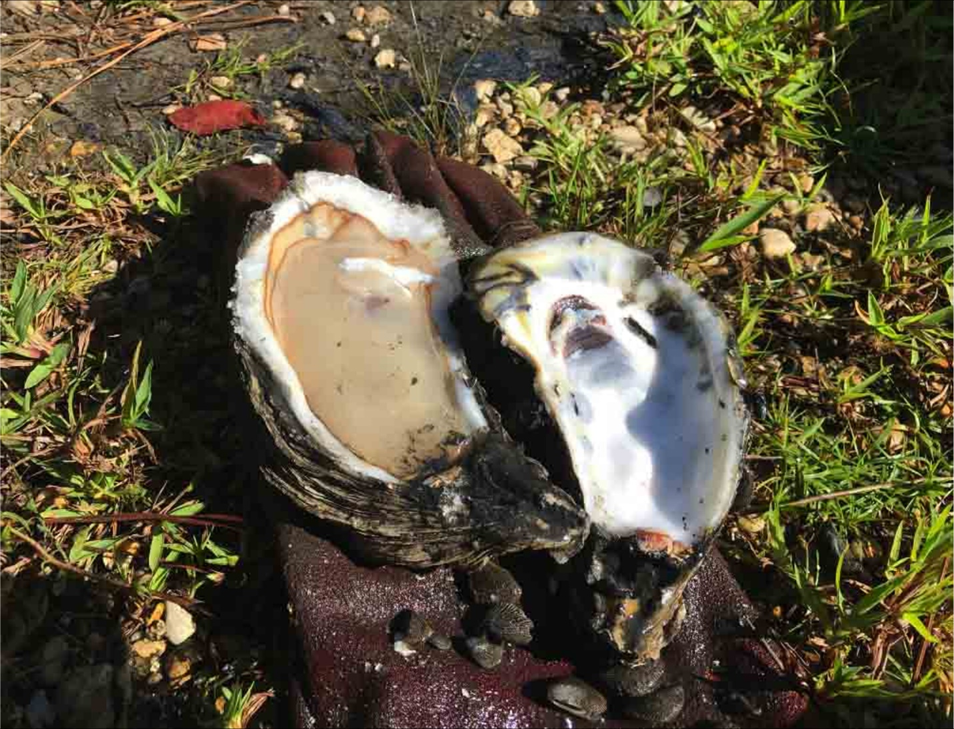
William Burton Fears, M.D., F.A.C.P
ROCS International is sending this White Paper to Various Agencies Around the World because, for my family there is no time to do this any other way.

Table of Contents
1…………………Illustration and Figure 1 - Crassostrea virginica (Gulf Oyster)
3.…………………………………………………………………………Goals and Purposes
4………………………………………………………........................... General Concepts
6………………………………………………………………………………………………………………. Background
Page 9-Figure 2………………………………………………………………………………………Chemistry
10………………………………………………Shell Mass per Metric Ton Equivalent of C02
Page 11-Figure 3………………………………………Lime Rich Oyster Bed Clutch Choices
17………………………...Sustainability, Social License, and Environmental Justice
16……………………………………………………………………………………………………………Action Plan
18…………………………………………………………………………………………. Bibliography

Contributions were made by scientific experts around the world that I have had the opportunity to work with including David Moore, U.K; Robert Waldron, Louisiana, U.S.; Carolina Bourque, Louisiana; Peter Petros, Finland, Matthias Heilweck, France, Dr. Rebecca Albright, California; Departments of Parks and Wildlife, Texas and Louisiana, Todd Moon, U.S., and many others who also want a sustainable solution to climate change.

Goals and Purposes
Planetary Bioengineering is the process by which living things that did arise on this planet have been modifying their habitats on earth since they first appeared. “Modifications that include the greening of earth by photosynthetic organisms, which turned a predominantly reducing atmosphere into an oxidizing one, the consequent precipitation of iron oxides into iron ore strata, and the formation of huge deposits of limestone by calcifying organisms. 1) the frequent involvement of marine calcifying organisms (coccolithophores, foraminifera, mollusks, crustacea, corals, and echinoderms), that have been described as ecosystem engineers modifying habitats in a general positive way for other organisms, and 2) the frequent involvement of humans changing the earth's biosphere in a generally negative way for other organisms. the fossil record shows that ancestral marine calcifying organisms had the physiology to cope with both acidified oceans and great excesses of atmospheric carbon dioxide periodically throughout the past 500 million years, creating vast remains of shells as limestone strata in the process. Therefore, it is our core belief that humankind must look to the oceans for a solution to present day climate change. The marine calcifying organisms of this planet have a track record of decisively modifying both oceans and atmospheres, but it may take millions of years to do it. On the other hand, humanity works fast and in just a few thousand years we have driven scores of animals and plants to extinction, and in just a few 100 years we have so drastically modified our atmosphere that, arguably we stand on the verge of extinction ourselves. Of all earth's ecosystems, those built around biological calcifying organisms, which all convert organic carbon into inorganic limestone, are the only ones that offer the prospect of permanent net removal of carbon dioxide from our atmosphere. These are the carbon removal biotechnologies we should be seeking to exploit.” (Moore et al., September 15, 2022.)

ROCS International Inc.

ROCS International (Restore Oysters for Climate Sustainability) is a nonprofit that believes that the first and most important approach is a massive effort aimed at restoring Oyster reefs and providing shoreline habitat for corals, crabs, shrimp, plankton, and other calcifying shellfish. This is because 90% of many of these creatures have been eliminated from the worlds’ shoreline habitats.
The sole purpose will be the support and finance of these efforts which are already underway, and those that will be established in the future deemed by the board of directors to be eligible for assistance.
Second, we plan to explore new ways to quantitate the amount of shell produced in those areas where shell is produced, farmed, or restored, so that the results of our efforts may be more easily quantified to establish the amount of carbon removed from the ocean and consequently, the atmosphere which is in equilibrium with it.
Importantly, it does not matter if a citizen does or doesn’t like Oysters, their harvest can be used as a source of high-quality supplements and feed for other animals as the shellfish meat has unsaturated fat and is high in omega-3 fatty acids. In addition, those left in situ will contribute the most to CO2 reduction.
Most importantly is that this elegant model for the removal of Carbon Dioxide should be embraced by all political parties and scientists. Who would not want to reestablish our shoreline habitats, improve fisheries, and support coral, while benefiting from the natural filtration and purification of our oceans?
The main point of this paper is that we need to produce shell from all organisms that make it because calcium carbonate or limestone is 40% carbon dioxide and that is in equilibrium with the atmosphere!

General Concepts

Our approach aims to maximize the production of shell and therefore removal of CO₂ from the atmosphere in our world’s oceans. First, Ocean calcifying organisms form calcium carbonate (=limestone) in their shells using CO₂ from the atmosphere in equilibrium with the surface Ocean. As the shellfish cultivation industry is one of the few industries that can increase the amount of Carbon capture exponentially while being sensitive to Ocean Ecosystems, we propose establishing essential infrastructure to change the aquaculture paradigm so that shellfish producers greatly expand production specifically to generate more shell for both harvest and restoration. Most harvest would be from accepted farming methods whereas restoration will use the application of calcium carbonate and shell to rebuild reef, thus magnifying the effect of establishing further shell and so forth.
Established oyster beds/reefs were fished out in the 18th and 19th centuries by dredging to harvest oysters as cheap human food for the growing cities of North America and Europe. By the early 1900’s, 90% of oyster beds had been fished out. At that time New Yorker’s ate an average of 300 oysters per year purchased on the street. Now they eat 3 per year because they are expensive and rare. Production was also diminished for both fisheries and Oysters by pollution due to sewage outflows and oil spills.
Clearly, a large part of the decline in production is also due to the habit of not returning the shell into the Ocean to provide the natural alkalinization and structure for new shell formation. Shell has been used for road construction, landfill, and calcium feed supplement.
We propose to establish essential infrastructure by acquiring funding through governments, donations, NGO’s, and nonprofits, in order to direct funding to those on the front lines to change the paradigm to re-establish the reefs and the bivalve population.
Therefore, our primary goal is the re-establishment of coastal systems in the United States and in the World at large.

The re-establishment of coastal systems is the most important step that the world can take to mitigate climate change because much of the infrastructure is already in place, and more importantly, because of the lack of time until climate change cannot be mitigated sufficiently by other methods carbon capture and storage.

Background
Input 1 (juvenile animals): The farming cycle begins with the collection of larvae, which may be gathered in the wild or produced in farm hatcheries (depending on the species and location). Oyster larvae are kept suspended in tanks by circulating water until they transform into oyster spat or oyster seed. [Clam larvae are kept in hatchery tanks where they transform into seed; Mussel larvae transform to juvenile animals; Scallop larvae settle and become juvenile animals]. Farmers acquire clam and oyster seed at various stages of its development, depending on the requirements of their operation. The seed is put into a nursery environment where it is nurtured into juvenile animals. The juvenile animals then graduate to the grow out phase of their development during which they mature to marketable size.
Input 2 (hardware facilities):
- ONSHORE industrial plant to treat, store and transport the harvested shellfish (refrigeration, road transport, etc). Temperature-controlled hatcheries. Electricity consumption of onshore facilities is the principal carbon cost/environmental burden of cultivating bivalves.
- OFFSHORE fishing vessels to manage and harvest the farms (still powered by diesel fuel, so these are the major contributors to the carbon cost burden). Offshore floating (licenced) aquaculture farms (called tenures in British Columbia) according to species. [Mussels are relocated to deep water tenures where they are suspended on ‘ropes’ or in mesh ‘socks’ to mature to marketable size over a period of 18 to 36 months. Oyster juveniles are moved to cages through which ocean water is circulated around trays of juvenile animals. When they are large enough, young oysters are moved to be reared in a grow out cages suspended from rafts, longlines or in intertidal locations.
No other inputs required:
- Bivalve molluscs and the other marine calcifiers (crustacea, corals, coccolithophore algae) don’t need farmland, don’t need freshwater irrigation, don’t need supplementary fertilisers. They just use (a small part of) the 70% of the Earth’s surface that’s covered in ocean.

Outputs
At least HALF the fresh weight of bivalve molluscs is made up of shell which is composed of calcium carbonate. This is stable for millions of years and represents atmospheric CO₂ PERMANENTLY removed from the atmosphere (we have fossil mollusc shells hundreds of millions of years old). You can’t say that for a herd of cows because they sequester carbon only temporarily (when the cow dies the carbon in its biomass will be digested and returned to the atmosphere, only the skeleton remains and that’s made from calcium phosphate).
- Published data demonstrates that long lines mussel farming is by far the world’s most productive meat-production method, currently yielding 150 to 300 metric tonne per hectare per year. To put these figures into perspective, beef production is only around 0.34 tonne per hectare per year, almost a thousand times less!
- A human subsistence diet requires about 180 kg of grain per person per year, and this can be produced on 0.045 hectares of land. In contrast, an affluent high-meat diet requires at least four times more grain (and four times more land, 0.18 hectares) because the animals are fed on grain and conversion of grain to meat is very inefficient. As it stands, the Earth does not have enough land for all its inhabitants to enjoy an affluent high-meat diet.
- There are old records of oyster beds over 200 km long and 30-40 km wide off the European coasts (that were fished out in the 1800s) and they must have been of similar size in US waters. You’d need a hell of a herd of cattle to match the biomass in those beds. Pity we destroyed almost all of them in the 1800s. They need to be restored to their former glory.
- Commercially grown bivalves are the only sustainable form of human food that has no negative impact on the environment This is because bivalve molluscs offer several ecosystem services that add value to their environment beyond their food value.
- Clams in Scotland have 1/18 the carbon footprint of beef and Oysters 1/3 the carbon footprint of beef when used as human food. This could easily be eliminated with the use of alternative energy sources and increasing the production which is low relative to the effort required to harvest 1/100th of what we were eating 300 years ago. But more importantly, restoration of the coast with shell in the abundance of 300 years ago would result in pure carbon resorption from the ocean and atmosphere in addition to what is used for food which would be a small fraction of total shell production by the ocean.

These additional bivalve ecosystem services in the habitat restoration context are:
  - Turbidity reduction by filtration.
  - Bio deposition of organics containing plant nutrients.
  - Induction of denitrification associated with organic deposition.
  - Sequestration of carbon
  - Provision of structural habitats (reef structures) that promote diversity of fish, crustacea and other organisms.
  - Habitat and shoreline stabilization.
  - Bivalves don’t require feeding.
  - Bivalves build food security.
  - Bivalve cultivation is more ethical than terrestrial farming.
A great variety of cultch materials (foundations for Oyster reefs) has been spread on the Madison Bay leases over several years, including cracked brick, crushed concrete, Rangia cuneata clamshell, broken cinder block, and shucking house oyster shell, all materials high in Calcium Carbonate by nature.
Pediveliger stage oyster spat can be found setting on substrates as diverse as sunken wood, crab traps, oil field scrap, creosote piles and burnt paint cans, but tend to thrive upon living reefs in the presence of dissolved Calcium. To survive, seed oysters build shell rapidly, and for this purpose, they may employ the help of an enzyme catalyst, called Carbonic Anhydrase, which evolved first with the archaic prokaryote bacteria, but which is now found in all organisms (including human tissues) on Earth; a splendid example of convergent evolution. This enzyme is the catalytic key to bivalve shell formation, though its widespread distribution in other organisms (bacteria, animals, plants and fungi) is due to the crucial part it plays in managing the CO₂ to bicarbonate transition in many different steps in metabolism and many different cells and tissues.
In oysters, carbonic anhydrase is found in the oyster’s mantle tissue, where it regulates and accelerates interconversion between CO₂ and bicarbonate, leading to the eventual deposition of Calcium Carbonate.

SHELL FORMATION
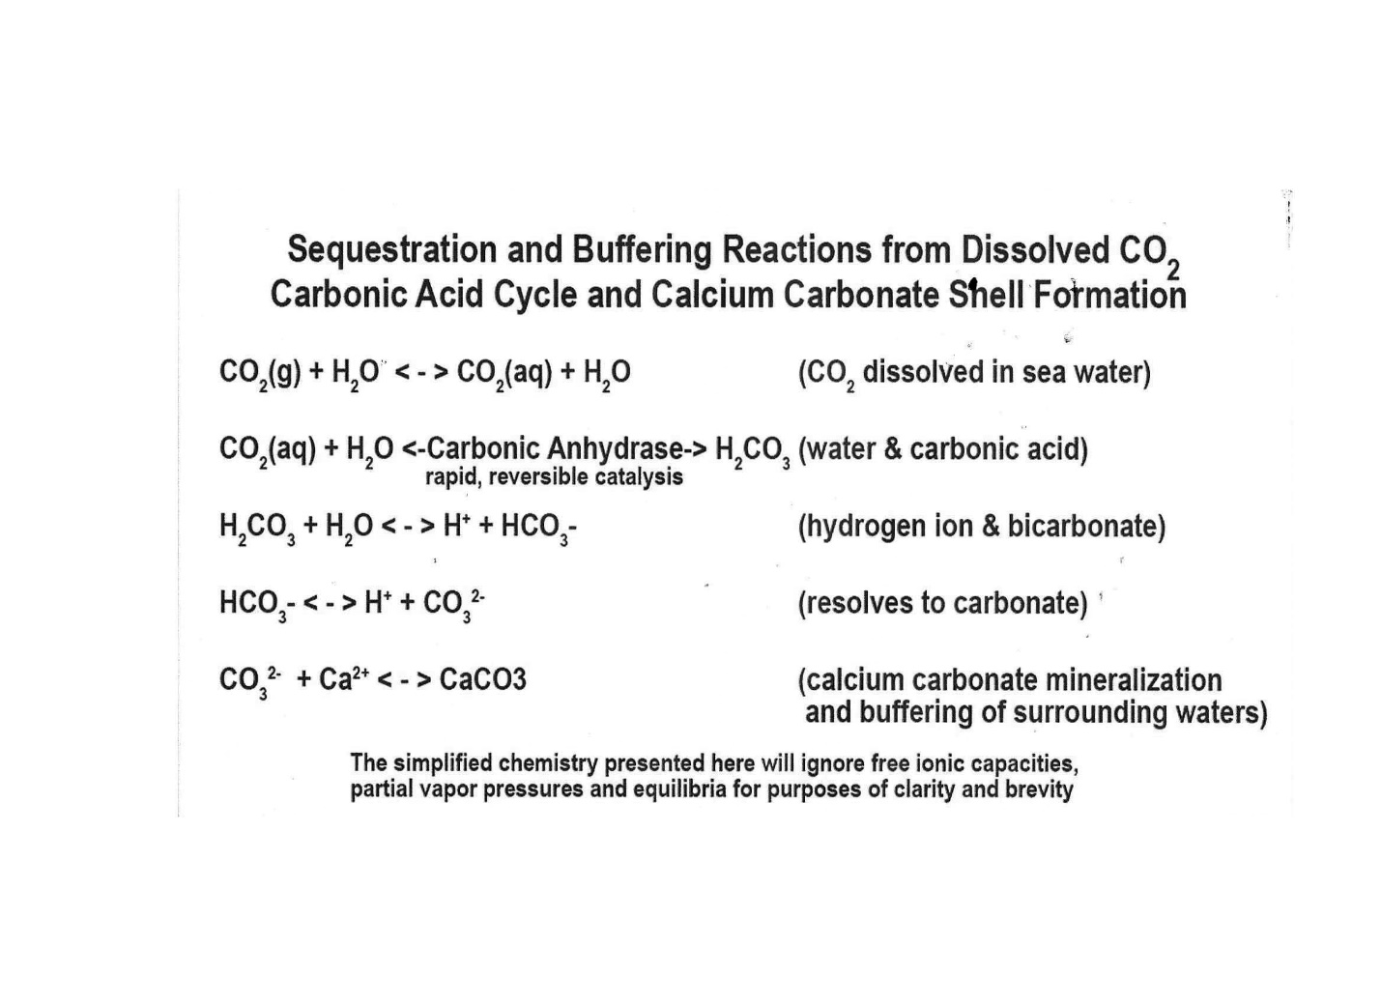
Figure 2

Carbonic Anhydrase acts as the critical catalyst, greatly increasing the effectiveness of the sequestering reaction in finally depositing Calcium Carbonate. A single zinc atom has the most important effect and placement within Carbonic Anhydrase molecules, which can alternatively be termed ‘metalloenzymes’.
Indeed, even our folklore memorializes the Zinc of Gulf oysters because optimal Zinc levels are necessary to testosterone production and prostate health in human males. In Louisiana, they say it and post it on bumper stickers ‘Eat Oysters, Love Longer’.
The Louisiana Oyster Cultch Project (2013 – 2016) (10) estimated 200 cubic yards of shell or other cultch bedded to each acre of state seed grounds. In such a harvesting regime, landings could be calculated for final shell mass and converted to mTe at a rate of around 0.378 metric tons CO2 per yd.3 of bleached shell, which could represent 75.6 mTe total sequestration per acre. Tennessee’s ‘Pine Scenario’ project has only offered 4 mTe carbon credit per year per acre. Gulf oyster ‘shell neutral’ harvesting processes might be said to represent almost 19 times more carbon sequestration per acre than do worldwide reforestation / afforestation projects.

Oster Shell Mass per Metric Ton Equivalent C0₂
- 1 cubic yard Bleached Oyster Shell Weighs 1 US Ton
- 1 US Ton × 0.95 (= proportion of CaCO₃ in Oyster shell) = 0.86 mT/ cubic yd
- Molar Mass of CO₂ = 44
Molar Mass of CaCO₃ = 100
Therefore, proportion of CO₂ in CaCO₃ = 44/100 = 0.44
- Consequently, applying this molar conversion factor, 1 US ton oyster shell = 0.86 × 0.44 = 0.378 ton of CO₂.
- Overall, then, for the purpose of permanent sequestration of atmospheric carbon, 1 cubic yard of Bleached Oyster Shell contains 0.378 ton of CO₂.
Figure 3
Thus, this animal and those like it (clams, scallops, snails, coral reefs) not only filter the water and create an environment for all coastal life but, right under our noses, they sequester gigatons of carbon dioxide on a massive scale. So, it becomes obvious that the destruction of the reef system over the past 300 years has had a devastating effect on the carbon cycle.
THE GOOD NEWS IS THAT CLIMATE CHANGE CAN BE REVERSED AND GIGATONS OF CO₂ CAN BE PERMANENTLY REMOVED FROM THE ATMOSPHERE JUST BY CULTIVATING SHELLFISH!
THE CARBON THAT IS PERMANENTLY SEQUESTERED IN THE SHELLS OF DEAD SHELLFISH IS THEIR LEGACY TO THEIR HABITAT. TREES, SO OFTEN THOUGHT OF FOR IMMEDIATE CARBON SEQUESTRATION, OFFER NO SUCH LEGACY FOR THEIRS IS A TEMPORARY STORAGE. DEAD TREES DECAY AS THEIR TIMBER IS DIGESTED BY MICROBES AND INSECTS, AND IN A FEW MONTHS OR YEARS THE TREE’S ‘SEQUESTERED’ CARBON IS RETURNED TO THE ATMOSPHERE!

Lime-Rich Oyster Cultch Choices
• Oyster Shell & Crushed (1.5-inch) Oyster Shell
• Crushed Limestone - Crushed (#610) Concrete (averaging 1/4 inch to 1 inch size pieces of recycled concrete)
• OysterCrete™ (Portland Cement, Fly Ash, Oyster Shell)
• Cracked Pavestones (Sand, Pea Gravel, Portland Cement)
• Cracked Brick
• Broken Cinder Block Decomposed Granite (CaO Component) & Terra Cotta (Roman Empire technology) among others
Figure 3

Louisiana State agencies have reported that natural oyster shell for planting has increased in price over the past 5 years, from roughly $15 per cubic yard (yd³) to between $25 and $35 per yd³. This has resulted in increased costs to maintain Louisiana oyster fishing grounds, public and private alike. Modern oyster culture requires water bottom management and sustainable cultch regimes so that the species can remain as both a primary food source and an important operator in the act of carbon sequestration and coastal acidification buffering.
It is hoped that public and private oyster interests work toward crop sustainability in part, by claiming international carbon compliance offset profits for all the work done by our favorite seafood. At the same time, it will provide a sustainable source of protein for any animal from cattle supplement to fish food as well as food for starving millions of men, woman, and children on this planet. I am not a fan of carbon credits simply because we all just need to work together to get this done and nothing will replace stopping the use of fossil fuels. althoughthe use of shellfish could be used in the carbon offsetting markets to make certain that the “polluter pays” by providing direct financial reward to cultivators for farming shellfish for their shells.
Sustainability, Social License, and Environmental Justice

As stated at the beginning, this solution should be embraced by both political parties because businesses will be supported that are already operating and new businesses will be created. All of this will happen in areas of the country that were income levels are lower and fishermen are struggling as well as many in the tourist industry.
Currently, operating shellfish farms are removing 1 million tons of Carbon from the atmosphere at 10% of the capacity that existed at the beginning of the 18th century. This is due to established oyster beds/reefs being fished out in the 18th and 19th centuries due to overfishing and dredging to harvest oysters as cheap human food for the growing cities of North America and Europe. Raw Sewage, Oil Spills, and pollution have compounded the problem. This is not just an Oyster problem but since they clean water, provide habitat, and provide food for all animals, it is a catastrophic environmental justice problem.
Our team plans to employ a two-pronged Ocean approach to restore and maximize the removal of CO₂. First, Ocean calcifiers form calcium carbonate in their shells, turning CO₂ from the atmosphere into limestone. CO₂ in the atmosphere is in equilibrium with the surface Ocean. We propose to first establish foundations, enlist governments and the media and so forth so that the people and the environment will benefit. Our goal would be to restore shellfish production and consequent removal of carbon to pre-industrial levels. Second, we plan to conduct a medium phase study on alkalinization of the beds/reefs to test whether this fosters increased calcification.

Project Location
Currently, I am in contact with key players in the Oster Industry in Texas and Louisiana. The Department of Parks and Wildlife regulates these industries, and each state has committed biologists working with the industry. Once we have funding, we will work with the biologists in each state to begin the experimental protocol to see if oyster calcification can be increased. It will then need to spread around the world to amplify and feed the world!

Demographic Information
Louisiana demographic data shows an African American population of 59.5%, White 33.9%, Asian 2.91% Two or more races 1.92%. Louisiana, as you know, has suffered multiple blows with the Covid pandemic and Hurricane Katrina just being two of them. New Orleans has the highest poverty rate (18.6%) in the United States. Successful implementation of our team’s approach will help alleviate and possibly eliminate that problem. My mother grew up without a father or mother in that area and was raised by loving sisters. When I used to visit at age 5, the Gulf was as clear as the Caribbean. Costal restoration is being implemented in the Chesapeake Bay and Manhattan as well as Georgia and Louisiana but they need more funding.

Any Additional Environmental Burden
For the most part, in my mind, the largest environmental burdens have been inadvertently imposed by the fossil fuel industry. There are many chemical plants in the area as well as offshore drilling. Recently, a proposal by President Biden to stop drilling on public lands was overturned by one judge! The beaches used to be a bright white sand along the gulf coast and now they are a grey mud flat. Birds and other wildlife have been decimated by oil spills. Giving the fishing industry money in restitution does not restore the gulf back to its former glory, it insults mother nature.

Legacy Pollution Analysis
Well, of course we have the BP oil spill which got the most headlines and, indeed, was catastrophic, but there are also smaller chemical and oil spills that occur with regular frequency along the coast. Many of these are not traceable to a capped well or to a pipeline until dead birds and fish begin washing up on the shore. Then, there is a photo op for the cleanup which consists of people in hazmat suits mopping the beach with rags. As far as I know, mopping the beach with rags has virtually no effect. Thank God that there are organisms that evolve to eat oil and plastic. The problem is that it has been incorporated in our food chain. Our worlds valid concern is that they cannot eat all the chemicals, oil, and plastic in the world’s oceans until we have mass extinctions, hopefully not our own. I have a beautiful granddaughter who was just accepted to college program in the 8th grade. We are so proud of her but is she going to have the same or a better world to live in than I did growing up? I am now aged 76; when I was her age I could stand on the pier on the Gulf of Mexico and see Blue Crabs in 15-feet of water.

Negative Environmental Impacts
As far as the drive to increase and employ the shellfish industry, the only negative environmental impact is that of fuel that is being burned by the craft that are used to gather seafood.
12,000 years ago, men lived off the Florida coast on Oysters, shrimp, crab, and fish for thousands of years without any environmental impact. They had enough shell in Southeast Florida left over to build a pyramid the size of the Pyramid of Giza.
We need to incorporate clean energy into our strategy for managing these fisheries. Shore boats can be powered by batteries. Solar and other clean energies should be utilized to the maximum extent. About the experiment that involves local alkalinization, the oceans are becoming more acidic due to the increases in CO₂ in the atmosphere. Dr. Rebecca Albright was able to show a 7% increase in calcification with local application of dilute levels of sodium hydroxide (lye) on coral reefs which is why we intend to do the study we propose. The protocol is designed to begin with levels which most simulate her study and local and frequent surveillance by trained biologists will assure that there is no negative effect.

Positive Environmental Impacts
The most important Environmental Impact will be mitigation of climate change. The reduction of CO₂ in the atmosphere could literally slow down the submergence of our shores which threaten to place entire cities underwater!

What Steps Have We Taken to be Assured That Voices in the Community are Heard and That Their Concerns are Being Met?

I have been in contact with many stakeholders, including oyster fishermen, wildlife agencies around the country, biologists, biologists, NGO,s and citizens who just have an interest in climate change and restoration of the reefs.
I think that this could be one of the best things that could happen to this coastal community. Increased funding will assure adequate funding of the industry and development of potential ways to produce more shell. Much of the funding should be used in a large public relations campaign which shares what is being done with the citizens of each state so that they may take advantage of the new job opportunities that will inevitably result.
The effect on poverty could be profound, providing jobs, infrastructure, clean energy, food, and recreation. In Texas, a regulation was just passed to restore shell to the ocean. The shrimp and oyster industry have been decimated in Texas to the point that the harvest had to be suspended this year. To help this industry recover, economies will need to be developed which gather shells from all the restaurants that serve oysters, large projects to lay down cultch and food production. But primarily we are interested in the production of shell. Also, although raw oysters were a major food source in the past, they are good to eat in many other recipes beside the raw state and are now completely healthy and safe to eat, being tested at qualified labs. They are not harvested in area which could be contaminated.
Also, a massive increase in production will also provide feed stock for fish farms and prevent the harvesting of smaller fish for that purpose which depletes the fisheries. Many jobs will be created as the result of billions of dollars being poured into the fishing industry, the tourist industry, and just providing food security for the world. All this, and they will also clean the water of particulates by filtering the water as they have done for millions of years.

ACTION PLAN
1. First recognize that Ocean Calcifying marine organisms remove CO₂ permanently from the atmosphere. Switching to clean energy is likely to be too slow to stop climate change at the current rate of decrease in the use of fossil fuel. Active biotechnological carbon removal and Ocean healing must be included in our strategy. Engineering strategies alone may help but cannot come close to matching biological engineering.
2. The shellfish shells need to be restored to the ocean floor or reef to facilitate the production of more shellfish. Otherwise, the fisheries will remain as barren as they have been for the past century. Oysters used to be abundant, and, 200 years ago, were a major source of food in New York and other major cities. Interestingly, an African American oversaw the Oyster Industry in New York at its height when 300 to 1000 Oysters per year were consumed per person. Now it is 3 Oysters per year and 90 to 95% of the Oysters are gone along with crabs, shrimp, and many other seafood harvests that depend on them.
- There are staggering business opportunities in collecting cultch material to spread on shellfish fisheries and all the steps to restoration but there must be initial funding to stimulate the formation of these industries by the Government, NGO’s, corporations, or just Billionaires who want to reverse climate change until enough natural shell is being generated.
- At first, other materials will need to be used to supplement shell because over the last 300 years the natural shell has been harvested so relentlessly that barren oyster fisheries have resulted.
- The industry will need funding for expansion and production of the shellfish larvae (called spat) which can be farmed in a variety of ways including, cages, ropes, and in specified areas rotated on the bottom as would any other crop.
3. The meat from the shellfish is high quality protein that is also high in omega-3 fatty acids, essential vitamins, and minerals such as zinc which can be commercialized for a variety of uses.
- As today, Oysters are shucked and eaten all over the world but in much smaller numbers than 300 years ago. Still, they can be fried and used for sandwiches which many people in our society have missed out on because their price puts them in the food delicacy bracket rather than the staple food category. New York had at least on hundred recipes. Of course, clams are used in delicious pasta dishes and chowders as well - eating shellfish is a win-win - fine food and you save the atmosphere!
b. This high-quality protein can be used for fish farming and almost every kind of protein supplement from high protein drinks, hospital total nutrition, to food for cattle, chickens, and any other animal farmed or raised for food, as well as pet food. This solution will be essential in helping to feed the world as terrestrial farming will not be sustainable.
4. Other types of calcifying organisms such as marine algae, called coccolithophores, could be farmed on a large scale for the removal of large quantities of carbon and they provide food for the shellfish as well.
5. The total cost of mitigation of climate change when profits are subtracted, and taxes paid will be negligible comparted to any other form of carbon removal from the atmosphere.
6. Planting trees, although helpful and desirable, will not result in permanent removal or the same extent of removal per acre as blue carbon shellfish cultivation.
7. Funding needs to be appropriated as soon as possible to get started before it is too late to mitigate the climate change which is already in progress.
8. I strongly recommend that readers obtain and read the following book: Moore, D., Heilweck, M. & Petros, P. (2022). Aquaculture: Ocean Blue Carbon Meets UN-SDGS. A volume in the Sustainable Development Goals Series. Springer, Cham. ISBN: 9783030948450. 253 pp. URL: https://link.springer.com/book/10.1007/978-3-030-94846-7.

Bibliography

Moore D., Heilweck, M. & Petros, P (2022). Planetary bioengineering on Earth to return and maintain the atmospheric carbon dioxide to pre-industrial levels: assessing potential mechanisms. 15Sept2022, Front Astro. Space Sci. 9,797146. https://doi:10.3389/fspas.2022.79146
Moore D., Heilweck M. & Petros, P. (2021). Saving the Planet with Appropriate Biotechnology: 1. Diagnosing the Problems. Mexican Journal of Biotechnology. 6(1): 1-30. DOI: https://doi.org/10.29267/mxjb.2021.6.1.1.
Moore D., Heilweck M. & Petros, P. (2021). Saving the Planet with Appropriate Biotechnology: 2. Cultivate Shellfish to Remediate the Atmosphere. Mexican Journal of Biotechnology. 6 (1): 31-91. DOI: https://doi.org/10.29267/mxjb.2021.6.1.31.
Heilweck M. & Moore D. (2021). Saving the Planet with Appropriate Biotechnology: 3. The High Seas Solution. Mexican Journal of Biotechnology. 6 (1): 92-128. DOI: https://doi.org/10.29267/mxjb.2021.6.1.92.
Moore D. (2021). Saving the Planet with Appropriate Biotechnology: 4. Coccolithophore cultivation and deployment. Mexican Journal of Biotechnology. 6 (1): 129-155. DOI: https://doi.org/10.29267/mxjb.2021.6.1.129.
Petros, P., Heilweck, M. & Moore, D. (2021). Saving the planet with appropriate biotechnology: 5. An action plan. Mexican Journal of Biotechnology, 6 (2): 1-60. DOI: https://doi.org/10.29267/mxjb.2021.6.2.1.
PRE-PRINTS on ResearchGate:
Petros, P., Moore, D. & Heilweck, M. (2022). Planetary bioengineering on Earth to return and maintain the atmospheric carbon dioxide to pre-industrial levels: Assessing potential mechanisms. Frontiers in Astronomy and Space Sciences, in review 2 November 2021. ResearchGate preprint, DOI: https://doi.org/10.13140/RG.2.2.10773.40167.
Moore, D., Heilweck, M., Petros, P., Moore, R.J. & Squires, S.J. (2022). Calcifier Myths Dispelled: “Ocean Acidification” and “Shell Making Produces CO₂”. ResearchGate preprint, DOI: https://doi.org/10.13140/RG.2.2.20184.37128.
Moore, D., Heilweck, M. & Petros, P. (2022). Aquaculture: Ocean Blue Carbon Meets UN-SDGS. A volume in the Sustainable Development Goals Series. Published by Springer Nature Switzerland AG. ISBN: 9783030948450. 286 pp. In Press release planned for mid-April 2022. URL: https://link.springer.com/book/9783030948450 [view on Amazon].
Rosa Perfetto, Sonia Del Prete, et al Cloning, expression, and purification of the α-carbonic anhydrase from the mantle of the Mediterranean mussel, Mytilus galloprovincialis; Journal of Enzyme Inhibition and Medicinal Chemistry Volume 32, 2017 – Issue 1
Subhas AV, Adkins JF, et al Catalysis and Chemical Mechanisms of Calcite Dissolution in Seawater; Proceedings of the National Academy of Sciences, 2017 DOI: https://doi.org/10.1073/pnas.1703604114.

The Business of Carbon Credit Trading for Forest Landowners; Department of Forestry, Wildlife &fisheries,UniversityofTennesseeExtensionServicePublicationhttps://extension.tennessee.edu/publications/Documents/W217.pdf
The‘GoldStandard’NGOWebsite https://www.goldstandard.org/resources/afforestationreforestation-requirements
Climate Policy Initiative, California Carbon Dashboard http://calcarbondash.org
Anne S. E. Nielsen, Andrew J. Plantinga, and Ralph J. Alig, New Cost Estimates for Carbon Sequestration Through Afforestation in the United States https://www.fs.fed.us/pnw/pubs/ pnw_gtr888.pdf https://www.ucdavis.edu/news/calcium-carbonate-and-climate-change Michele Regina Rosa Hamester; Palova Santos Balzer; Daniela Becker Characterization of calcium carbonate obtained from oyster and mussel shells and incorporation in polypropylene; Materials Research vol.15 no.2 São Carlos Mar./Apr. 2012
Thomas M. Soniat, John M. Klinck, et al A Shell-neutral Modeling Approach Yields Sustainable Oyster Harvest Estimates: A Retrospective Analysis of the Louisiana State Primary Seed Grounds; Journal of Shellfish Research, Vol. 31, No. 4, 1103–1112, 2012 10. Louisiana Natural Resource Trustees, Louisiana OysterCultchProject,revised Nov. 2014 https://www.gulfspillrestoration.noaa.gov/sites/default/files/wp-content/uploads/LA_PI_OysterCultch_Project_Monitoring-Plan_111714
Waldron, Robert Paul, B.S., B.M., M.A.: Is Crassostrea virginica gulf oyster reef a sustainable resource subject to equivalent carbon credit trading on the world cap & trade market? Robert Paul Waldron, B.S., B.M., M.A. presented to National Shellfisheries Association ‘Aquaculture 2019’ February 2019 - New Orleans,
Dr. Rebecca Albright, Reversal of ocean acidification enhances net coral reef calcification: Nature: Vol 531:17 March, 2016
Gagern, Antonius et al, September 9th, 2019, Meeting Proceedings on Ocean Alkalinity Enhancement, current state of knowledge and potential role of philanthropy.

Fears, William Burton, M.D., F.A.C.P.,
White Paper, Climate Change, Carbon Capture and Environmental Justice,
Envirohomeusa.com
513 Bent Creek Dr.
DeSoto (Dallas County),
Texas 75115

